**RE: Well Status Update**

**11/03/24**

Testing continues on full water system, with results indicating Wells will require additional treatment on Monday and Tuesday, with testing to follow. **BOIL ALERT** and Stage 5 restrictions remain in place until further notice. Thank you for your continued support.

*See Previous Messages Below.*

**UPDATE #8**

**RE: Well Status Update**

**11/01/24**

The ground storage tank tests have come back NEGATIVE. The tests for both Wells and the furthest distribution points have come back POSITIVE as of yesterday afternoon. Samples were taken again last night and sent to the lab this morning. Results are expected by tomorrow morning. Test results must conform with TCEQ guidelines 100% prior to moving forward.

* If these tests come back positive again, we will then need to proceed with chlorine shocking the wells.
* If these tests come back negative, we will be able to rescind the water boil at that time.

We remain on **BOIL ALERT** until notified otherwise.

*See Previous Messages Below.*

**UPDATE #7**

**RE: Well Status Update**

**10/26/24**

**Well #2** is back online. The PUD is now disconnected from the resort’s irrigation well. It will take two days to purge the ground storage tanks at which time we will begin testing the water on the storage tanks, distribution and both Wells. If all goes well and all tests pass, we will be able to rescind the water boil at that time – which we anticipate to be next Friday.

We remain on **BOIL ALERT** until notified otherwise.

***Once again, many thanks to the graciousness of Doug and Cindy Stevens for sharing their irrigation well water with the PUD.***

NOTE: Although we have removed the requirement to conserve water *due to the Well issues*, we are still on **STAGE 5** conservation.

*See Previous Messages Below.*

**UPDATE #6**

**RE: Well Status Update**

**10/22/24**

Regarding **Well #2**, our Well service company, *Advanced Water Well Technology*, is preparing the pump equipment and will be onsite this afternoon to begin the install. If everything goes well, they should be finished installing the pump and flushing Well #2 by Thursday or Friday of this week.  Following this, *MOC* will draw samples for bacteriological testing from both wells, ground storage tanks and distribution; all tests must pass in order to rescind the boil alert.

We remain on **BOIL ALERT** until notified otherwise.

We must still **CONSERVE WATER**.

*See Previous Messages Below.*

**UPDATE #5**

**RE: STATUS OF WELLS**

**10/17/24**

**Well #1** will be up and running this afternoon. Remember, this is not the primary well. Along with the Irrigation Well, we should be able to maintain adequate water levels during our conservation period. Our conservation period continues until further notice.

The failure of Well #1 was due to some type of electrical surge. The motor has been replaced and a control module has been upgraded to prevent this type of situation in the future.

The condition of this Well #1 deems it unsalvageable to be rehabilitated. It is good for providing water to supplement Well #2.

**Well #2** is scheduled for a jetting to remove any sediment down in the bottom of the hole. Reinstallation of this Well should occur next week once all materials are procured and brought onsite.

Continue to **CONSERVE WATER** as our big Well (#2) is offline.

We are still on **BOIL ALERT**.

**See Well #1 and Well #2 pictures below.**

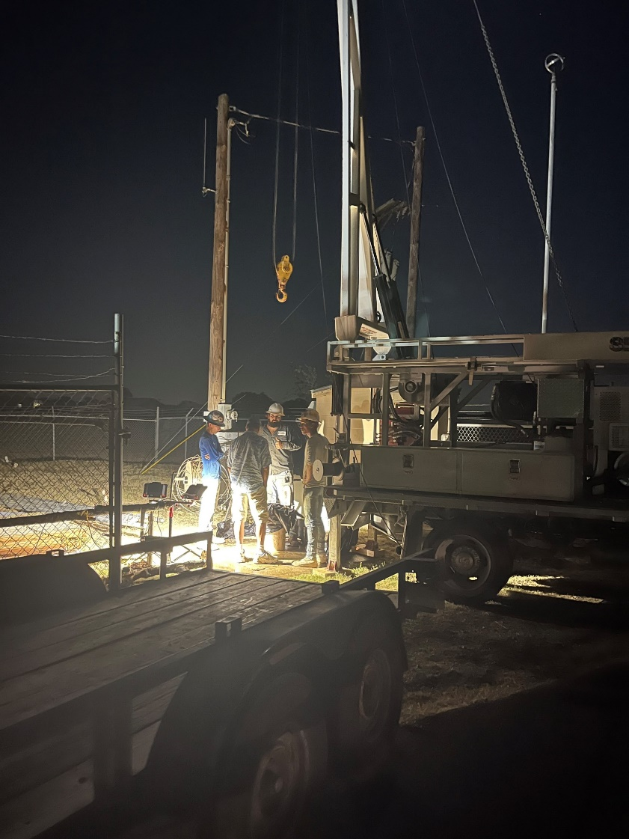

*Pictured above:* ***Well #1*** *- new down hole pipe installed last night.*

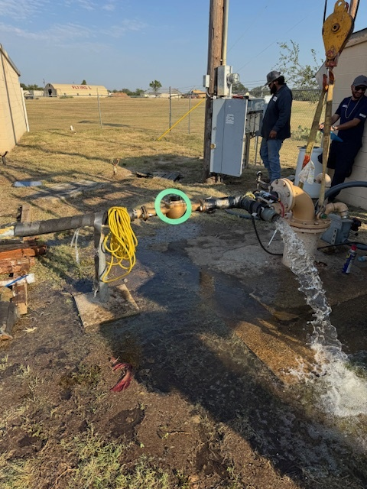

*Pictured above:* ***Well #1*** *- the purging of chlorine once it was brought back online.*

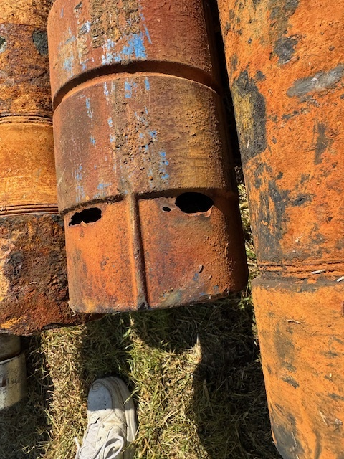

*Pictured above:* ***Well #2*** *- two good sized holes in a section of the down hole pipe; this is what caused the severe drop off in production.*

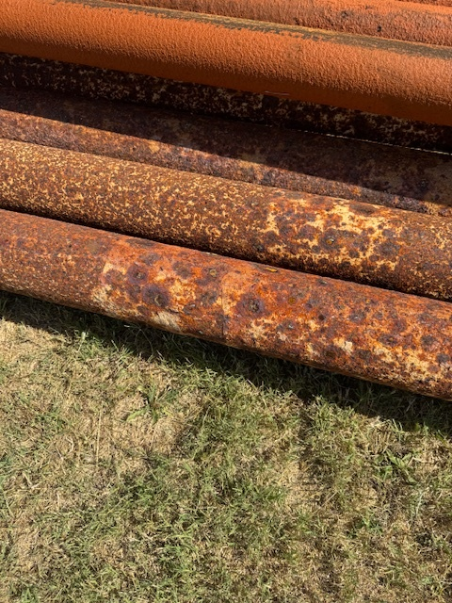

*Pictured above:* ***Well #2*** *- the condition of all the other down hole pipe.*

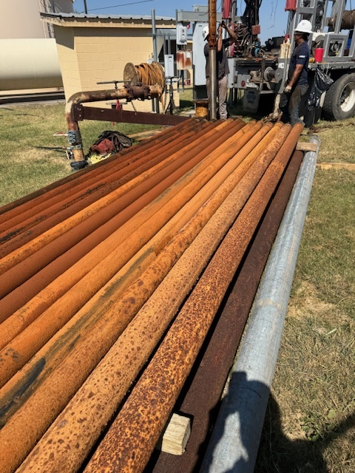

*Pictured above: This is all of the pipe pulled out of* ***Well #2****; note the one on the right; this is how all of the pipe started life.*

**See Previous Messages Below.**

**UPDATE #4**

**10/14/24 (afternoon)**

**Update on the Status of our Wells**

The Flying L PUD has two wells:

1. Well #1 (the original well)
2. Well #2 (the one that produces most of our water)

**How we got here:**

A few weeks ago, the Board received a report from GM Services who performed the annual inspection of our Wells; we reviewed the report with our operator, and also got in touch with Advantage Well (a Well service company) to be sure a qualified person was reading the report and making the assessment.

Advantage Well informed us that the reports showed that Well #1 was operating intermittently and Well #2 production had decreased; however, the water levels were fine – but there was most likely a hole in the pipe coming from the pump to the surface. They gave an estimated date of October 16 to have Well #1 back online and steady.

On Thursday, October 10, our operator noted production in Well #2 was dropping further and called Judd to inform and discuss. Judd called Advantage Well again and asked if we could expedite bringing Well #1 back online asap. At that time Advantage suggested pulling Well #2 on Monday, October 14 to lessen the down time.

**What corrective and/or proactive action(s) were/are being taken:**

On Friday, October 11, Judd Ryan (Board President) located and personally paid for water to be delivered by 3pm on Saturday, October 12 and again on Tuesday, October 15. (This company was a no-show on Saturday and both requests to them for water have since been cancelled.)

Meanwhile, Judd, along with the assistance of the Board (Leslie, Bob and Will) and a handful of others in the community, spent all of Saturday, October 12 (9am – 9pm) on continued efforts to locate water sources and haulers to help replenish the holding tanks as well as organizing the process that would need to occur.

The **secured water source was the City of Bandera**; the City agreed that our water hauler could fill the tanker truck multiple times from the City hydrant. Although permission was granted, it was not feasible to be granted unlimited access.

Various members of the “team” that was assembled on October 12 put the tools in place to be able to transport potable water from the City to our tanks.

The **secured water hauler was Wildebeasts**; they showed up on Saturday, October 12, and began hauling water from the City to our tanks. This process continued into the evening on Sunday, October 13, as the hauler had to leave at that point to report to South Carolina for their crisis. At this point, the City hoses and meter will no longer be used and will be returned to the City.

Fortunately, early on in this crisis, **resort owners Doug & Cindy Stevens graciously gave us permission to tap into their irrigation Well** to assist with keeping available water to the community while our Well #1 and Well #2 pumps were pulled and repaired.

The piping installation to tap into the Resort’s irrigation Well was secured and the work is completed. We sent a BOIL ALERT as is required by TCEQ.

**Anticipated timeframe for all to be back in place and working as usual:**

We are waiting on information from Advantage Well as to the extent of damage to both Wells and the availability of parts.

This is all the information we have at this point. As things change we will keep you updated.

**What everyone can do to help**

We have many residents that only use 1,000 or 2,000 gallons per month and on the flip side 20% routinely use anywhere from 10,000 to as much as 30,000 gallons every month.

Be mindful every time you open your water faucet inside your home, “flush” judiciously, turn the faucet off when you brush your teeth, use a dish basin for washing dishes (use the same water) or use your dishwasher (it’s been reported that washing by hand uses more water), put off anything that you can that would require using water unnecessarily.

Use as little water as possible.

**See previous messages below.**

**UPDATE #3**

**10/14/24**

The water district is issuing a BOIL WATER ALERT effective immediately. The duration of the ALERT will continue until further notice.

We are still in Stage 5 restrictions.

Our wells are not producing water. Our water usage has increased and we cannot replace the water at the rate of usage.

We must RESTRICT WATER USE.

Further information will be provided later today on flyinglpud.com.

**See previous messages below.**

**UPDATE #2**

**10/12/24 (afternoon)**

It is important to still **REFRAIN FROM USING WATER** until further notice.

Per **Stage 5** restrictions, you should have already TURNED OFF sprinkler systems, irrigation systems and pool autofill systems.

**We are also asking you to refrain from running your laundry.**

We are in a critical situation now as water was not adequately conserved since the first message went out on Thursday, 10/10/24.

**See previous messages below.**

**UPDATE #1**

**STATUS UPDATE RE: WATER CONSERVATION**

**10/12/24**

Until further notice later today, in order to buy us more time to correct our water situation without further incidence, all residents must **STOP USING WATER** **immediately**.

Both tanks *still have water*; however, based on the water report for the last 24 hours, there is apparent continued regular usage, and the water levels in both tanks are now dangerously at 4 feet.

Water is being trucked in this afternoon so that we can run off of it - while the wells are removed, repaired, and put back into operation.

We started the process of securing outside water yesterday, and we are still working on securing other interim solutions.

* 18,000 gallons are being trucked in this afternoon. This is all we can get today, until Tuesday.
* 42,000 gallons will be trucked in on Tuesday.

**The community ran through 40,000 gallons of water in the last 24 hours. All residents must STOP USING WATER until further notice later today.**

**See previous message below.**

**ORIGINAL NOTICE**

**A MESSAGE FROM THE PUD BOARD OF DIRECTORS**

**RE: IMMEDIATE WATER CONSERVATION**

**10/10/24**

The Flying L PUD, in the spirit of community and transparency, is going to require your attention and support for a **critical infrastructure repair** for our water supply system that cannot be delayed.  Our wells and pumps are working very hard to sustain function, though are at their margins doing so.

We hope to begin this process tomorrow, Friday 10/11/24, and intend for it to be complete in the shortest duration possible; the contractor is estimating 15 days, better if able.

During this time, we will have boil water notices as wells are taken offline and put back online. We are also requesting your full cooperation in limiting your water consumption behavior to critical service only.  Simply stated, no pool, lawn or vehicle maintenance during the period of time while repairs are underway.  You *should* *not* see a reduction in water pressure, though we must conserve our resources to the best of our ability.  Our pumps are at their limit keeping our auxiliary tanks at capacity.

We’ve all seen how SC, TN and FL are able to bring their communities together to solve much more serious issues than we face, and ask that you engage that same spirit of cooperation to address an urgent need here at the Flying L.

We thank you.

**END OF MESSAGES**